**Executive Summary:** *The State of Iowa Cancer Trends, Causes and Predictions*

**1. Objective / Purpose**

The purpose of our research is to analyze and identify key factors contributing to the rising cancer rates in Iowa. Using publicly available state and federal health data we have placed emphasis on finding the causation of the rising rates for breast, prostate, melanoma of the skin and lung cancer.

**2. Key Findings**

* **Melanoma Breast Cancer and Prostate Cancer:** There is strong correlation between binge drinking and these cancers. It is likely due to alcohol's tendency to damage one's DNA.
* **Lung Cancer:** Lung cancer cases often reveal that patients have elevated cholesterol levels and high blood pressure. It is likely caused by the lifestyle of Iowa’s dense rural population.
* **Overall Cancer Rates:** A larger scale driver of rising cancer rates in Iowa can be attributed to limited preventative healthcare due to Iowa’s strong rural population.

**3. Visuals**

**Lung Cancer – High Blood Pressure**  **Lung Cancer – High Cholesterol**

**Breast Cancer – Binge Drinking**  **Prostate Cancer – Binge Drinking**

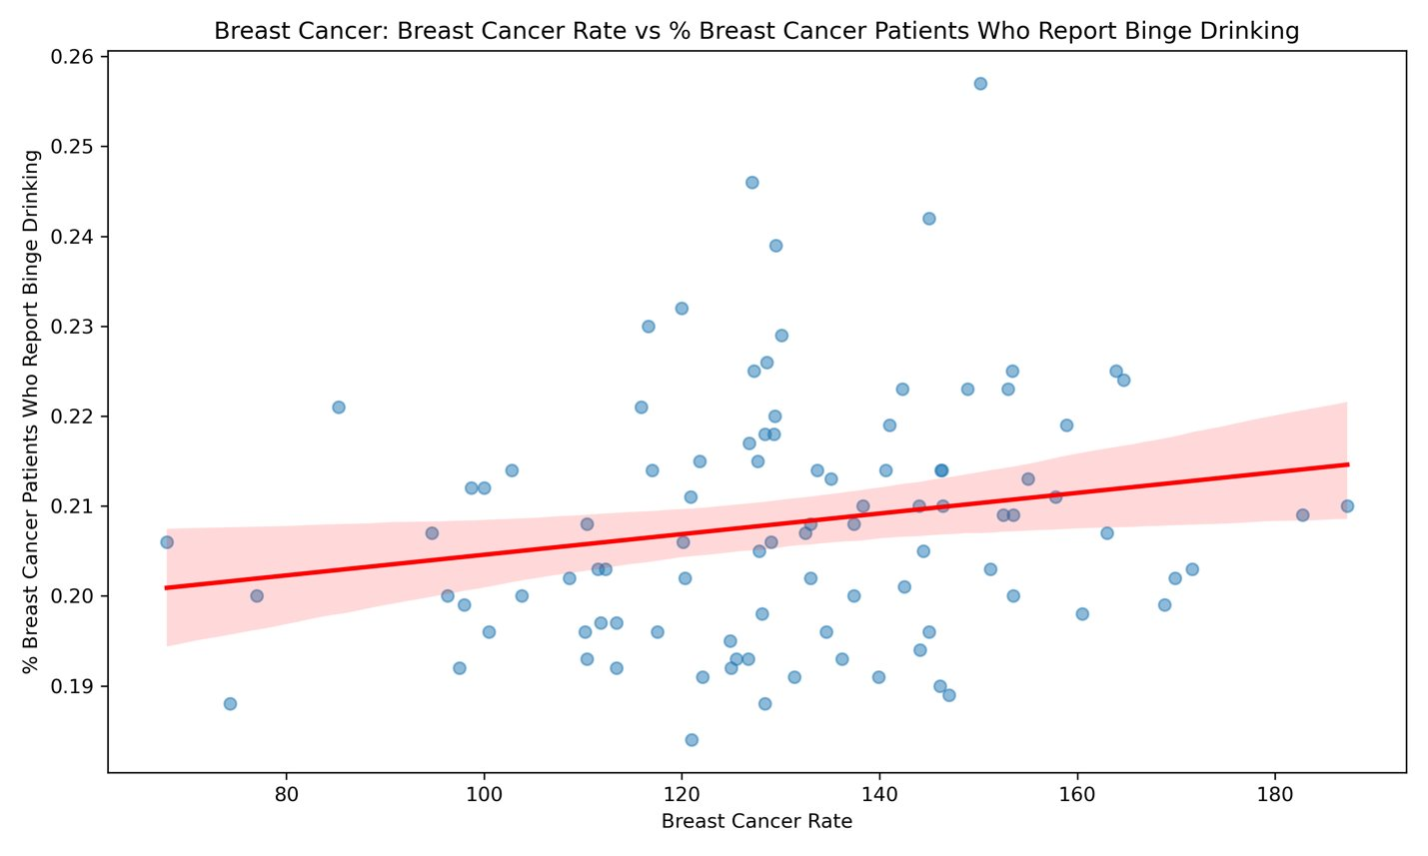

**Melanoma of the Skin – Binge Drinking**

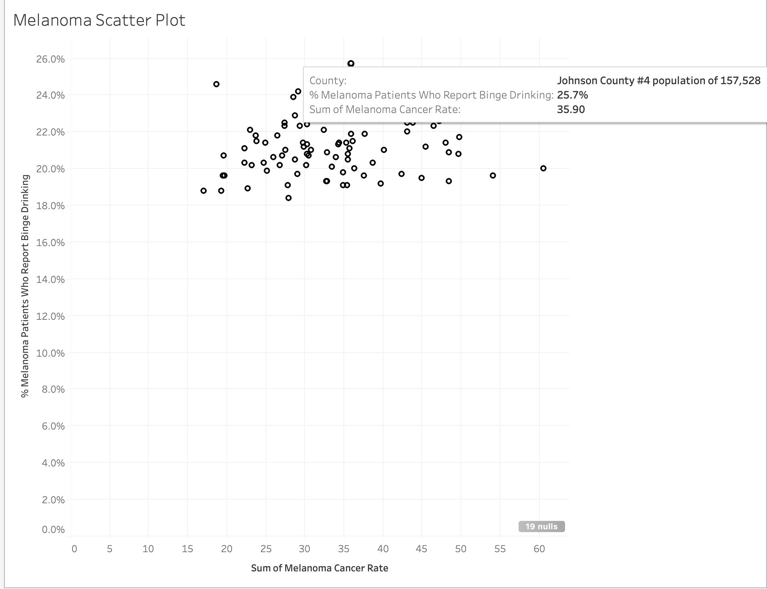

**4. Recommendations**

* Offering a 10% insurance premium discount to 1,000 high-risk individuals
* Launch a local TV campaign in high-risk regions (Iowa Risk Score heat map)
* Track Campaign Effectiveness: Measure total TV viewership, monitor website traffic and sign-ups